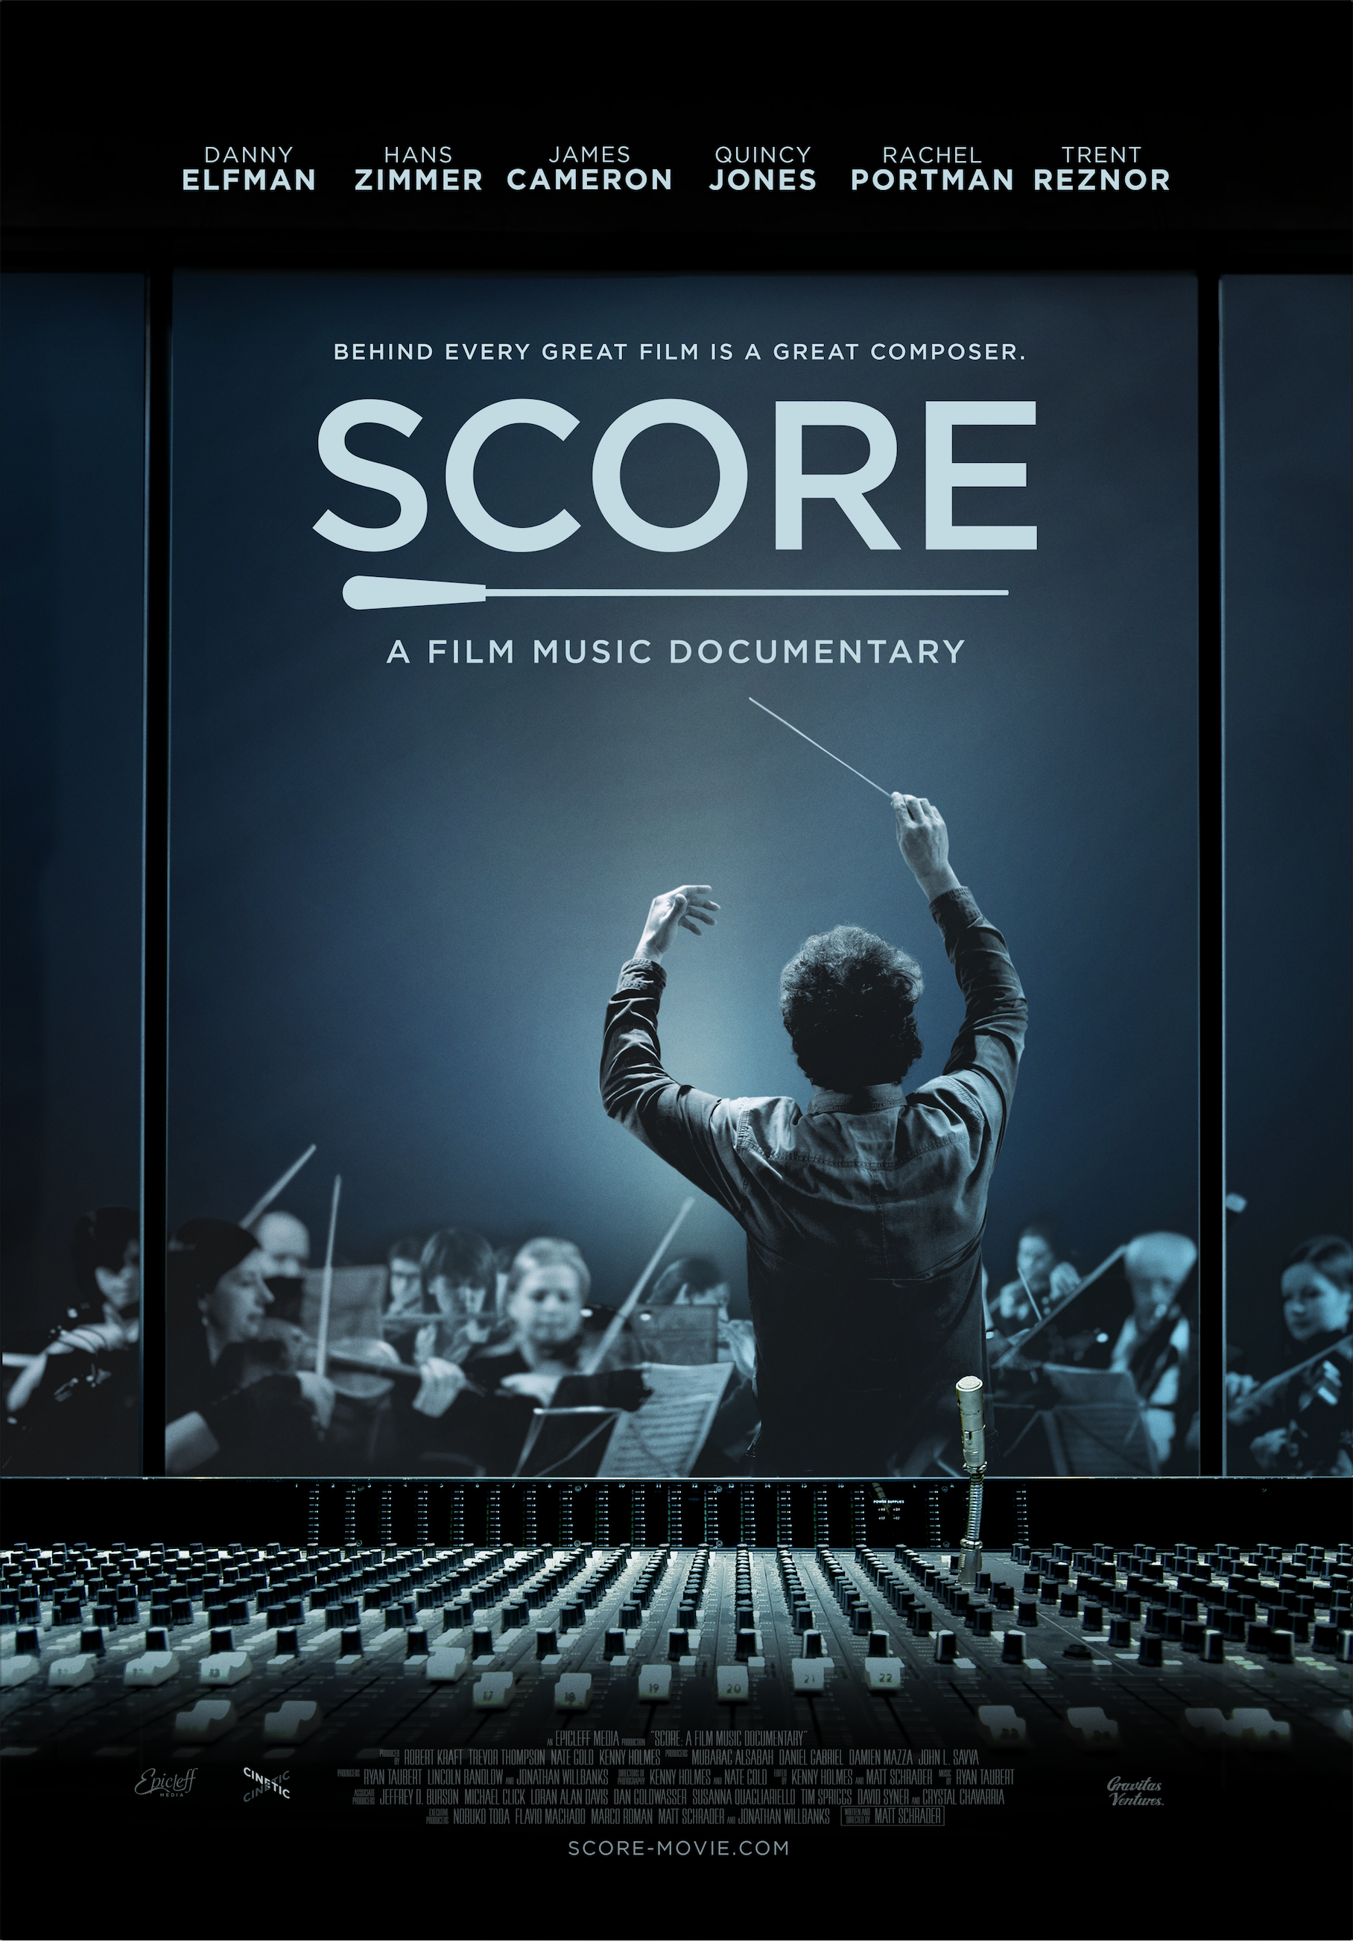

SCORE: A Film Music Documentary

Directed by Matt Schrader
93 minutes, English, 5.1 surround

SCORE-MOVIE.COM
facebook.com/scoremovie
twitter.com/scoremovie
instagram.com/scoremovie
CONTACTS

International Sales
Jason Ishikawa, Cinetic Media jason@cineticmedia.com
Shane Riley, Cinetic Media shane@cineticmedia.com

Filmmakers
Epicleff Media info@epicleff.com
Producer Jonathan Willbanks: jw@epicleff.com
Director Matt Schrader: ms@epicleff.com

FILM SUMMARY

Cinema’s most celebrated composers reveal the musical challenges and creative secrecy of big-budget blockbuster film scores, while exploring the greatest movie music of all time.

FILM SYNOPSIS

What makes a film score unforgettable? Featuring Hans Zimmer, James Cameron, Danny Elfman, John Williams, Quincy Jones, Trent Reznor, Howard Shore, Rachel Portman, Thomas Newman, Randy Newman, Leonard Maltin, and the late James Horner and Garry Marshall, SCORE: A FILM MUSIC DOCUMENTARY brings Hollywood's elite composers together to give viewers a privileged look inside the musical challenges and creative secrecy of the world's most international music genre: the film score.

Film composers are tasked with crafting the emotional heartbeat of films, creating a musical storylines that can enhance or even purposely play against the picture to achieve the desired emotional effect on the audience — sometimes inspiring strong emotions from audiences around the world.

The documentary contains interviews with dozens of film composers who discuss their craft and the magic of film music while exploring the impact of influential scores throughout history, including James Bond, Star Wars, Indiana Jones, Pirates of the Caribbean, Titanic, The Social Network, Mad Max: Fury Road, and Psycho.

CAST

David Arnold
Tyler Bates
Christophe Beck
Marco Beltrami
Paul Broucek
Jon Burlingame
James Cameron
Mychael Danna
John Debney
Alexandre Desplat
Patrick Doyle
Danny Elfman
Steve Erdody
Dave Ewart
Bill Field
Elliot Goldenthal
Harry Gregson-Williams
Tom Holkenborg / Junkie XL
Steve Jablonsky
Henry Jackman
Quincy Jones
Joe Kraemer
Richard Kraft
Robert Kraft
Mitchell Leib
Shawn LeMone
Christopher Lennertz
Deborah Lurie
Leonard Maltin
Dario Marianelli
Garry Marshall
Bear McCreary
Moby
Mark Mothersbaugh
Amos Newman
David Newman
Randy Newman
Thomas Newman
Heitor Pereira
Conrad Pope
Rachel Portman
John Powell
Trevor Rabin
J. Ralph
J.A.C. Redford
Trent Reznor
Atticus Ross
Doreen Ringer Ross
Buck Sanders
Howard Shore
Siu-Lan Tan Ph.D.
Steven Spielberg
Robert Townson
Joseph Trapanese
Brian Tyler
Mervyn Warren
John Williams
Christopher Young
Hans Zimmer

FILMMAKER BIOGRAPHIES

Matt Schrader (writer-director-editor) is a three-time Emmy Award-winning news producer and filmmaker and a graduate of the University of Southern California’s School of Cinematic Arts. As a special projects producer for news agencies including CBS and NBC, his stories have changed lives, laws and resulted in millions of dollars returned to consumers and communities. In 2014, he left his career in news to pursue SCORE: A FILM MUSIC DOCUMENTARY, which became one of the most popular crowdfunded documentary projects of all time. Matt attended the USC Annenberg School for Communication and helped found and grow the Southern California Business Film Festival in 2008. SCORE: A FILM MUSIC DOCUMENTARY is Matt’s first feature-length documentary, and you can connect with him on Twitter at @mattschrader or though SCORE’s Facebook page, www.facebook.com/scoremovie.

Robert Kraft (producer) is the former President of Fox Music, which produced Avatar, Titanic, Moulin Rouge and many more under his direction. An Oscar, Golden Globe and Grammy-nominated composer, Kraft co-produced all of the Oscar- and Grammy Award-winning songs in “The Little Mermaid,” including the Academy Award-winning song “Under The Sea.” Kraft is a member of the Music Branch of the Academy of Motion Picture Arts and Sciences.

Jonathan Willbanks (producer-executive producer) is a producer, entrepreneur and technologist who has consulted and spearheaded distribution for more than a dozen independent films. A graduate of USC's Business and Cinematic Arts joint program, his experience includes marketing and distribution for Disney Channel and The Moving Picture Institute, and technology-driven roles with GE, Apple and Verizon.

Kenny Holmes (producer-cinematographer-editor) is a producer and national award-winning news and entertainment photographer at NBC in Los Angeles. His photography has won several regional and national awards, including four Emmy Awards, the Edward R. Murrow Award for videography, and a National Press Club Award. You can connect with him on Twitter at @kholmeslive or though SCORE’s Facebook page, www.facebook.com/scoremovie.

Nate Gold (producer-cinematographer) is a director of photography and producer having worked on commercials, music videos, and features internationally. He is a graduate of USC’s School of Cinematic Arts. In 2010, he founded and now operates SoundBite Studios, a music studio facility in Los Angeles specializing in helping high-profile artists and creatives refine and realize their craft.

Trevor Thompson (producer) is an Emmy Award-winning journalist and a graduate of USC’s Annenberg School for Communication and Thornton School of Music. The son of BMI Award-winning composer Tim Thompson, Trevor’s creative journalism and powerful human interest pieces have broadcast on stations across the country as well as CNN.

Crystal Chavarria (associate producer) is a producer, production designer and art department coordinator whose work has appeared in productions for Disney, NBC, Fox, Showtime, The CW and Starz. She is a graduate of the USC School of Cinematic Arts, where she graduated cum laude with a degree in film production and production designed and costume designed award-winning student films.

REVIEWS / PRESS BLURBS
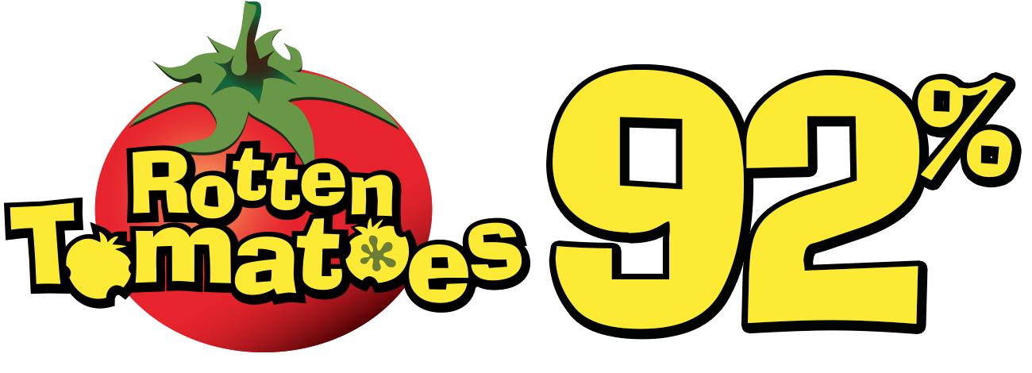
Rotten Tomatoes: Fresh
92% critics, 96% audience
rottentomatoes.com/m/score_a_film_music_documentary

The New York Times Critics’ Pick
https://www.nytimes.com/2017/06/15/movies/score-review.html

“Fascinating.”
Devan Coggan
Entertainment Weekly

“A feast for the eyes and ears.”
Gary Goldstein
The Los Angeles Times

“An absolute delight.”
Scott Weinberg
Nerdist

“Terrifically engaging.”
Sheri Linden
The Hollywood Reporter

“A jukebox of some of the greatest musical moments in film history.”
Jason Gorber
Birth.Movies.Death

“Excellent.”
Leonard Maltin
LeonardMaltin.com
“A celebration of the artists who create the musical heartbeat of the movies.”
Richard Roeper
Chicago Sun-Times

“A must see.”
Scott Mantz
Access Hollywood

“Enough to satisfy both film music novices and dyed-in-the-wool fanatics.”
Kenji Fujishima
Village Voice

“Engaging.”
Bruce Demara
Toronto Star

“A lively examination of the role of music in the movies.”
Chris Knight
National Post

FILM FESTIVAL AWARDS

- Winner, Boulder International Film Festival (Jury)
- Winner, Chicago Critics Film Festival (Audience)
- Winner, Cleveland International Film Festival (Audience)
- Winner, Gasparilla International Film Festival (Audience)
- Winner, Nashville Film Festival (Jury)
- Winner, Newport Beach Film Festival (Jury)
- Winner, Sedona International Film Festival (Jury)
- Winner, Tacoma Film Festival (Audience)

FREQUENTLY ASKED QUESTIONS
Note: Please attribute answers to Director Matt Schrader

Where did this idea come from?

SCORE: A Film Music Documentary started years before we knew it had begun. As a cinephile I’d long appreciated the music of film, and in the age of endless press featurettes for Hollywood productions, I’d hoped for a documentary about how film composers create scores. After a few years waiting, and pitching it to my good friend Trevor as something we could pursue, I left my job working for CBS to try to make SCORE.

What was the most difficult part of making SCORE?

Scheduling was an immense headache during production. What many people don’t know is that most prominent film composers are in extremely high demand, which means their schedules can be booked solid for months at a time while they’re trying to brainstorm, write, orchestrate, record and mix. We had to wait more than a year for one of our favorite composers, Bear McCreary, because he was working on six television shows and, as it turned out, the top-secret “10 Cloverfield Lane.”

How did composers receive your requests to interview them?

Most Hollywood composers are used to handling media or interview requests, though they don’t get as many as, say, a rockstar or movie star. For the most part, there’s a tight-knit group of journalists on the inside that cover trends in film music, which means everyone knows everyone. We had to break into that industry early on. At first people wondered if we were putting together a YouTube video or an educational video, but as our social media following grew, people started to hear about us. It was exciting to interview James Cameron and learn he was so excited to see the film (though we haven’t sent him a copy yet!)

Who was your favorite person to meet?

Hans Zimmer was very excited to be a part of SCORE. We chatted on a couple occasions about the direction of our film and who we hoped to include in it. He even offered to put us in contact with Thomas Newman, one of his favorite modern composers we tried to reach, though it didn’t work out in the end. Meeting Hans and his team at their studio in Santa Monica was a really mind-blowing experience.

Any surprises along the way, or did everything play out as intended?

Almost everything in our original gameplan changed at one point or another. We interviewed different people with different interests and talents and quickly learned we had the makings of something really unique. One of our favorite shoots was with Heitor Pereira at a scoring session, as he showed the orchestra how to play “dirty” by hand for a different kind of sound. It was amazing to see how orchestral instruments can be used as sound effects — and sometimes vice versa.

Did you ever worry you weren’t going to finish the film?

Some of us did; I never had any concerns. There came a point where I knew we had enough for a compelling documentary, and my focus changed a bit toward trying to improve the parts that needed work. It was hard to keep us all on the same page as we gathered hundreds of hours of footage, but in the end we were all very pleased with the result. We hope people will enjoy watching the film as much as we enjoyed making it.

